Document Title | Document Code | Document Type | Issue No | Sop No.
Software Development Lifecycle | S-SW-SD | SOP | 01 | 1
Issue Date | Effective Date | Copy No. | Revision No.
01/10/2025 | 01/10/2025 | Master | 0

Purpose
Manage the Software Development Lifecycle (planning, designing, implementing, testing, deployment) ensuring alignment with business needs, code quality, and timely releases.
Procedure & Flow
- Requirements & Planning
  - Software Manager and Business Analyst gather requirements from stakeholders (SRS, BRD, Product Backlog).
  - Software Manager and Software Supervisor System Requirements (Software & Hardware requirements).
  - Software Supervisor, Business Analyst and Developer Team breaks down tasks, estimates timelines (US, Sprint Backlog).
- Implementing (Design & Coding On TFS)
  - Software Supervisor coordinates with Developers Team and UI/UX Designer (Working on US and Tasks).
  - Software Supervisor follows UI/UX, coding standards, version control, and best practices (Code Review on TFS & Repository code Pull Request).
- Deployment (For Testing)
  - Software Supervisor Deploys on Test Environment Release test TFS.

- Testing & QA
  - Software Tester conducts unit, integration, Functional, non-functional and user acceptance tests (UAT) TFS.
  - Software Supervisor ensures code reviews and bug tracking.
- Deployment & Release (For Live)
  - Software Manager approves final build.
  - Software Supervisor Deploys to production (on-premises) Release Live TFS.
  - Software Supervisor Rollbacks plan in place if issues occur (Hotfix).
- Maintenance & Updates
  - Software Manager and Business Analyst Document changes, track user feedback for future improvements.
  - Developers Team fixes, Performance, updates feature post-launch.
  - Developers Team Retrospective Meeting.
Documents & Records
- Requirements documents, SRS, BRD, Epic, Feature, User Stories, Task, Bug (TFS).
- Source code repositories, code review logs TFS.
- Test plans, QA reports, deployment notes, user feedback, Retrospective Meeting.

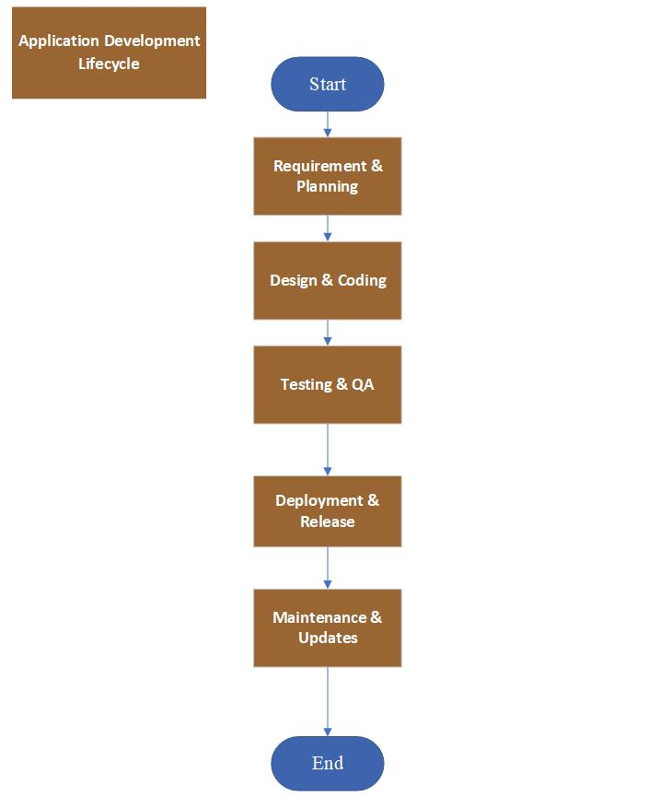
. Flow Chart

Forms
Form Name | Form Code
SERVICE REQUEST Form | F-SW-SD/01
Request Meeting in Minutes Form | F-SW-SD/02
Requirements List Form | F-SW-SD/03
Requests Log Form | F-SW-SD/04
Release Form | F-SW-SD/05
Release Log Form | F-SW-SD/06
Bug Form | F-SW-SD/07
Bugs Log Form | F-SW-SD/08
Feedback Survey Form | F-SW-SD/09
Feedback Survey Log Form | F-SW-SD/10
Retrospective Meeting Form | F-SW-SD/11
Product Backlog TFS
Sprint Backlog TFS
Task TFS
Bug TFS
Release Test TFS as Task
Release Live TFS as Task

Revision History
Rev No | Rev Date | Issue No | Issue Date | Description of Change | Approved By
0 | 01-10-2025 | 01 | 01-10-2025 | Initial Issue

